**Excel Lab: Creating Basic Charts**

This lab was completed as part of my “Data Visualization and Dashboards with Excel and Cognos” course. It helped reinforce my understanding of basic chart types in Excel, including how to filter data, use pivot tables, and apply visual formatting using Excel for the Web.

**Dataset**: Modified Car Sales Dataset from Kaggle



**1: Create a Column Chart.**

I created a 2-D Clustered Column Chart titled "Power Perf Factor of Toyota Cars" using filtered data for Toyota.

**2: Create an Area Chart**

I created a 2-D Area Chart for Toyota cars with data labels shown and the Unit Sales series filled in Gold.

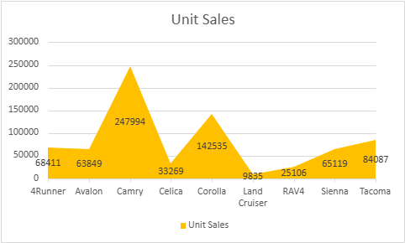

**3: Create a Bar Chart from a Pivot Table**

I created a 2-D Clustered Bar Chart from a pivot table filtered for Toyota, with data labels set to Inside End.

**4: Create a Line Chart from a Pivot Table**

I created a 2-D Line Chart with Markers for selected Japanese manufacturers. The chart title was "Average Retention % of Japanese Auto Manufacturers", data labels were shown below, and legend was removed.

